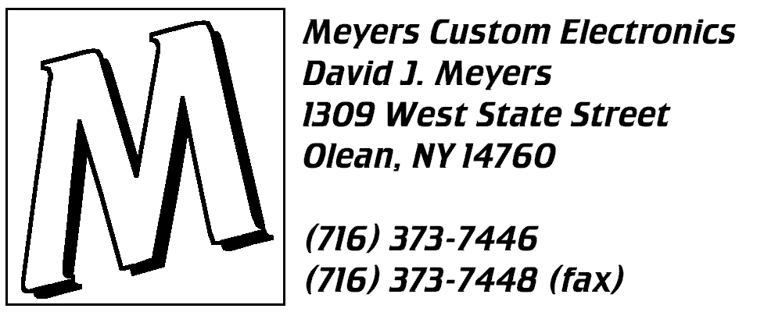

Cabinet Level Display (CLD) Installation Manual
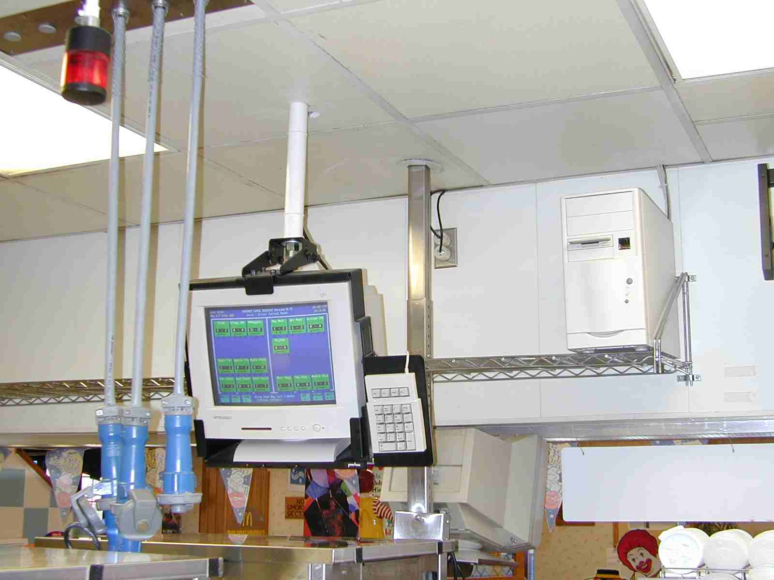
Unpack your system and check contents:
Your system will arrive in three boxes. One box contains just the monitor, another the computer, and a third contains the bracket, cables, and miscellaneous parts. If you have A PC-POS register system, the third box will also contain the switchbox and cables to connect your grill printer to the CLD. Unpack all boxes. You should have received the following:
- One computer.
- One keyboard.
- Two 3-prong power cords, packed with the monitor and computer.
- Two Twist-Lock power cords.
- Five 8-foot power extension cords.
- One 32-foot 3-headed Keyboard/Video/Keypad cable, with keyboard adapters already attached.
- One 100’ gray or white data cable, with metal connectors on each end.
- One monitor bracket, pre-assembled with a keypad and keyboard cable.
- A Plastic bag with tie-wraps and mounting squares.
- A licensed copy of Microsoft MS-DOS 6.22.
- A backup CD-ROM containing MS-DOS and the CLD software. Put this in a safe place. It is a backup of all software on your CLD. Do not use the CD to install MS-DOS on any other computer, or you will violate your Microsoft MS-DOS license.
- PC-POS only: Bitronics printer switchbox, power supply, 6-foot printer cable, 10-foot printer cable, gender changer, and 50-foot printer cable.
Determine component locations (Refer to FigureS 1-2 ON PAGES 16-17):
The CLD System is comprised of a mini-tower computer and a color monitor assembly. In addition, up to 2 remote screens may be added, typically for the fry station. The system can also be connected to your grill printer to allow the printing of stock lists and buffer slips.
The monitor should be located in the kitchen, directly above your UHC cabinets, facing the prep table. It should be positioned such that all grill-area personnel can see it without rotating the screen. In addition, the keypad should be easily accessible to most employees.
The computer may be located either in the grill area or in the office. Just make sure the computer and monitor are within 32 cable-feet of each other.
Finally, you will need to plug the computer and monitor into isolated-ground receptacles, either the twist-lock or the 3-prong type. Both cables are supplied with the system. These isolated-ground receptacles can be identified by their orange color. They are usually located above the ceiling behind the menu board, on the wall behind the menu board, and in the office. If you have no available receptacles, an electrician can either install a new one, or make you a Y-adapter.
PREPARING TO Hang the monitor bracket (Refer to Figure 2 ON PAGE 17):
The most difficult part of the CLD installation is hanging the monitor. If you have purchased an optional remote screen, then you will need to do this for both monitors. The monitor bracket is pre-assembled, so you only need to hang it from your ceiling. You will need to purchase the following items locally:
- One 3-foot length of ¾” diameter threaded rod.
- Eight ¾” hex nuts.
- Four ¾” flat washers.
- Five ¾” lock washers.
- One 3-foot length of 1¼” white PVC pipe.
- Two ½”x5” carriage bolts.
- Two ½” hex nuts.
- Two ½” lock washers.
- Two ½” flat washers.
- One 8-foot long 2-by-6 piece of lumber.
You will also need the following items:
- Screwdrivers.
- Wire cutters.
- Crosscut saw and hacksaw.
- Wrenches, Crescent Wrenches, or Channel-Locks.
- Vinyl electrical tape.
- An electric drill.
- A ½” drill bit, a ¾” drill bit, and a 1¾” hole saw.
In some cases, you may need a longer piece of threaded rod and PVC pipe. If longer pieces are not available, you can purchase a union to join two pieces of threaded rod together. If you have a solid ceiling, you will have to use a different method of attaching the threaded rod than discussed below. Refer to the detailed drawing at the back of this manual:
Hang the monitor bracket (Refer to Figure 2 ON PAGE 17):
- Remove the top plate from the monitor bracket, by loosening the hex nuts on the sides and removing the two socket-head machine screws. It is much easier to attach this plate to the threaded rod before you add the weight of the bracket and monitor.
- Remove the ceiling tiles around the desired monitor location.
- Locate the board above the ceiling, between two roof trusses. When you have it directly above the center of the UHC cabinet table, drill ½” holes in the 2-by-6 in the correct position and bolt the board to the trusses. Do not fully tighten the nuts at this time, because you will want to finalize the positioning later, in step (h).
- After the 2-by-6 is in place, mark and drill a ¾” hole in the board where the threaded rod will be located. Temporarily mount the rod in the hole. Reinstall the ceiling tile directly below the rod. Once you are satisfied with the positioning, lower the rod so it touches the tile and make a mark on the tile. Remove the tile and drill a 1¾” diameter hole in the tile centered on your mark. Approximately one inch away from the 1¾” hole, drill another hole in the ceiling tile for the cables to pass through.
- Remove the threaded rod and reinstall the ceiling tile. Now, if you want to avoid threading nuts all the way down the length of the rod, follow these directions carefully: From below the tile, insert the rod through the hole in the ceiling tile. Thread two nuts onto the rod, then one lock washer, and finally a flat washer. Turn these so at least 6” of the rod is above the nuts and washers. Push the rod through the board, place a flat washer on top of the board, then a lock washer, then thread a nut, lock washer, and another nut on the rod. Tighten the top 3 nuts as tightly as possible, to keep the rod from turning. Do not tighten the very bottom nut, though. Its purpose is only to keep the PVC pipe centered on the rod. Turn this nut until it is right in the hole where the rod passes though the ceiling tile.
- Measure the length of the rod showing below the ceiling. Cut the PVC pipe to this length. Clean the PVC pipe with degreaser and a green Scotch-Brite pad. Rinse and dry the pipe.
- At the bottom of the rod, thread a nut, a lock washer, and another nut on the rod. Leave about two inches of rod showing, and tighten the two nuts together. Slide the PVC pipe over the rod, and slide a flat washer, the black top bracket plate, and another flat washer onto the rod. Finally, thread a nut, lock washer, and another nut on the rod. Tighten the nuts together. They should be snug against the plate, but should allow some rotation of the plate.
- At this point, the two carriage bolts that hold the 2-by-6 to the trusses are still not tight. Move the 2-by-6 around until the threaded rod and PVC pipe are straight up and down. Tighten the ½” nuts until the heads of the carriage bolts just start pulling into the wood.
- Check all fasteners on the monitor bracket for tightness. Do not over-tighten the nuts with a wrench, because the ¼” bolts will snap. If the monitor was shipped with its tilt-base attached, remove it. (Yes, the photo on page 1 shows a monitor with the base still attached, but it is not sturdy enough.) Insert the monitor into the monitor bracket. Lift the monitor and bracket, and hook the hooks of the bracket over the two bolts sticking out of the top plate. Now, lift the front of the monitor until the front two holes line up. Insert the two socket-head machine screws, with their lock washers and flat washers, and tighten everything. If you need to adjust the height, loosen and adjust the nuts above and below the board.

Install the computer:
If you have valance shelving in your grill area, you can simply install the computer on the shelf. Another option is to set the computer on a shelf or cabinet in the manager’s office. The office location is a bit less convenient than the valance shelf, but it will result in fewer heat and contamination related problems.
Connect the monitor cables:
- Connect the monitor and computer to power receptacles, using the supplied 8-foot power extension cables and twist-lock cables. Wrap the connections with vinyl electrical tape to prevent them from working loose. Be careful not to tear the insulation on the ceiling grid, the roof truss, or grid-hanging wires. Obviously, the monitor power cable should pass through the hole you drilled in the ceiling tile.
- Pull the keyboard cable (pre-attached to the monitor bracket), keypad cable, and monitor cable up through the hole in the ceiling tile. Connect these to the 3-headed monitor cable. For your convenience, color-coded tie-wraps and connectors have been provided on all cables. Simply match up the colors. Screw and tape these connections as needed.
- Route the 3-headed cable to the computer, and connect it to the matching connectors. There are colored dots on the back of the computer, corresponding to the molded colors on the cable.
- Apply a couple of the supplied mounting-squares to the back of the monitor, and neatly bundle the cables behind the monitor with tie-wraps. Keep all 4 cables together all the way to the ceiling, and attach them to the PVC pipe.
- If you purchased a remote screen, run the remote screen cable from the remote screen to the CLD computer. The end of the cable with an orange or red tie-wrap connects to the connector on the CLD computer with a colored dot of the same color. The other end of the cable connects to the MODEM port of the remote screen. The remote screen will also need power from the isolated ground circuit.
PC-POS ONLY: CONNECT THE GRILL PRINTER INTERFACE
The CLD can print to any grill printer with a parallel interface. This means it can print to virtually any PC-POS receipt printer, including Star SP-300, Citizen CBM-231, and Epson TM-T88. Panasonic POS receipt printers have serial interfaces, and are therefore not compatible.
In order to be certain that your grill printer has a parallel interface, simply look at the data cable where it connects to the printer. A parallel printer has a 34-pin "Centronics" connector, which has two wire latches to hold the plug in place. If the back of your printer looks like the diagram below, you can connect it to the CLD:
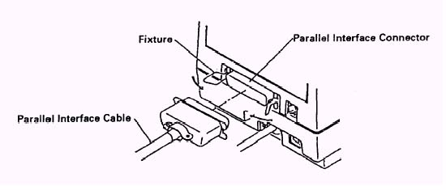
A Bitronics AutoSwitch shares the printer between the POS system and the CLD. You will locate the switchbox in the ceiling above the grill printer, connect the CLD computer and the printer to the switchbox with two new cables, and connect the switchbox to the printer-end of the existing printer cable using a "gender changer" adapter and another printer cable. Refer to Figure 4 (page 19):
- Make sure the four switches on the Bitronics AutoSwitch are in the positions shown on the diagram (1 & 4 OFF [up], and 2 & 3 ON [down]), and place in the ceiling above your grill printer.
- Shut down your CLD (if it is on) by pressing the “Esc” key, and entering the quitting password. This is usually your national store number. Power the CLD down.
- Using a screwdriver, remove the “Rainbow” brand hardware key from the printer port of your computer. This is a 25-pin connector that sticks out about 1-1/2" behind the CLD. It must be present for the CLD to work.
- In place of the hardware key, connect one end of the 3’ DB25 extension cable to the CLD.
- Reconnect the hardware key on the free end of the 3’ DB25 extension cable.
- Connect one end of the 50’ DB25 cable to the hardware key. Connect the other end of the 50’ DB25 cable to port "A" of the Bitronics AutoSwitch.
- Remove the existing data cable from your grill printer. Pull it into the ceiling.
- Attach the Gender Changer to the end of the existing printer cable. Then, attach the end of the 6’ Printer Cable to the Gender Changer. Connect the other end of the 6’ Printer Cable to port "B" of the Bitronics AutoSwitch.
- Connect one end of the 10’ Printer Cable to the grill printer, and connect the other end to port "PRINTER" of the Bitronics AutoSwitch.
- Power the CLD back on by pressing the POWER button on the CLD Mini Tower.

Power up, and make sure the CLD computer boots up successfully:
Turn on the computer and monitor, by pressing their large power buttons. You should have green lights on both. If you have a green light on the computer and an amber light on the monitor, you probably have a bad monitor connection. Double-check your connections. You should also have a green light on the keypad. If not, try pressing the [Num Lock] key or check your connections.
If everything is OK, the screen will come up with the CLD program. Since you have no recipes or product mix, all of the levels will be zero. Disregard any error beeps or messages about the system not being properly shut down. This may occur simply because there are no menu items yet.
If you connected a remote screen, power it up now. If the label at the bottom of the CLD color screen changes from MISC 1 to REM 1 or from MISC 2 to REM 2, then the CLD computer has detected the remote screen. If not, go into manager mode (by pressing 9) and then exit right back out by pressing the ESC key. You should also see a screen similar to the main CLD screen on the remote screen.
Test your grill printer (PC-POS Only.) First, make sure the crew can print grill slips from the registers. Next, print a stock list by pressing the 'PrtSc' key on the CLD keypad. If you have trouble printing, check your connections. In some cases, you may have to connect the supplied AC adapter to the Bitronics AutoSwitch to provide additional power.
Press the 8 key. The screen should go mostly blue, with some yellow letters. This is the data display mode screen. In this mode, the CLD system is displaying incoming order information from the registers. Since you haven’t connected the registers yet, there will not be any orders shown. If you have reached this screen, however, you know the CLD system is working properly. Leave this screen displayed while you connect the data cable to your registers.
Connect the data cable:
The data cable is the long, 100-foot gray or white cable. It has one large connector on one end, and a small one on the other end. The large connector attaches to the CLD computer, on the connector with the yellow dot. The small connector needs to connect to any register with an available COM port (called an “option port” on Pan 2+ plastic registers). On a Pan 2+ (metal) register system, this will connect to a printer interface box instead. In most PC-POS restaurants, you should connect your data cable to COM2 port of your Drive-Thru order-taker in the presenter booth. You cannot currently connect to a front counter register, because of a bug in the Store Systems 1 and 1.5 software. Do not connect to your Drive Thru cashier. The register may mistake the CLD for a coin changer, and will lock up your Drive-Thru registers!
How you connect the cable depends on your brand of registers:
Olivetti:
Connect to COM3. This is a small connector located on an expansion card, right above or below the touch-screen connector. The connector you want to attach to is on the same expansion card as a longer connector. Refer to your PC-POS manual for diagrams. Older Olivetti systems have two expansion cards that look alike, so you may have to use trial-and-error to find the one that is COM3.
PAR-4:
Connect to COM2. The connector is located on the bottom of the register.
Wang Javelin:
Connect to SER1, SER2, SER3, or SER4. Use the first one available. These registers use modular telephone-style connectors, so you must request an adapter cable when you order your CLD system.
Panasonic 2+ Plastic Registers:
Connect to an available option port on any available register. Front counter registers are preferable to Drive-Thru registers.
Panasonic 2+ Metal Registers:
You will need a dedicated printer interface box.

PC-POS Configuration (for Panasonic, skip ahead):
In this step, you will go into the register system and tell it to send all orders to the CLD screen. To do this, you have to tell the register system that you have connected a PARK/SERVE KVS monitor to the register. A PARK/SERVE monitor is one that is up front and displays all of the orders in the store. Since this is exactly the information the CLD needs, the CLD pretends it is a PARK/SERVE monitor. In fact, in the data display mode, the CLD acts just like a KVS monitor, so you can see when you have the right information going to it. You can follow along in chapters 4, 5, and 5A of your PC-POS manual. Write down this information before you start:
Register you connected the CLD data cable to: Register #___________
Port on the register that you connected the cable to (1-3): Port #__________
- Call me ahead of time, and I will give you the Super User password for the POS system. I will also walk you through the programming, if you like. It only takes about 15 minutes, if you are careful. Write the user ID and password I give you here. You will need these for the Hardware Setup. They will expire at the end of the day: User ID: ___________ Password: ___________.
- If you do not have an ISP, go straight to (c). ISP stores must do the following to put Register #1 in the Mini-OLC mode. Refer to page 4.60 of your PC-POS Manual (Release 3.52):
- Connect the CLD keyboard to the little keyboard connector on Register #1. Register #1 is also your Mini-OLC. You will use it to program the system.
- Enter manager mode on the register, using your own User ID and Password. Press the ACCESS OFFLINE BACKUP MENU button. Choose CONTINUE.
- The register will reboot, and ask you to connect a keyboard and press any key. Press the ENTER key immediately, or the register will reboot and you’ll have to start over.
- The register should then start up the Mini-OLC software.
- Press the F10 key until you log off, and the screen asks for your user ID.
- Log onto the OLC or Mini-OLC with the Super User ID and Password your Help Desk gave you.
- If the top of the screen does not say McDonald’s POS System Menu, press F10 until it does. Select Configuration Setup, and then Kitchen Video System.
- Setup the Monitor Location for the CLD:
- Using the arrow keys on the keyboard, select SYSTEM SETUP. Press the down arrow to select MONITOR LOCATION.
- Press the right arrow repeatedly until the cursor is on the line that corresponds to the register number you connected your CLD data cable to.
- In the LOCATION field, enter CLD (this is just your name for the monitor).
- In the TYPE field, enter PARK (for PARK AND SERVE monitor).
- In the BUMP field, enter BOTH.
- Do not enter anything in the ROUTER field. Press ESC when done.
- Enter the hardware setup information:
- Arrow right to REGISTER MAINTENANCE.
- Arrow down to REGISTER SELECTION.
- Enter the register number you connected the cable to, and press ENTER.
- Arrow down to HARDWARE SETUP, and press ENTER.
- Select CHANNEL 1 CONFIG and press ENTER.
- The information below should be correct for Olivetti 386/486 and Par-4 registers. If your POS system is not shown, your registers may need other settings that your help desk can provide.
- Press ESC once to exit.

 | Olivetti  COM1 | Olivetti  COM2 | Olivetti  COM3* | Par 4  COM1 | Par 4  COM2*
Comm Port | 1 | 2 | 3 | 1 | 2
IRQ | 4 | 3 | 4 | 4 | 3
Base Address | 0X03F8 | 0X02F8 | 0X03E8 | 0X03F8 | 0X02F8
Baud Rate | 38400 | 38400 | 38400 | 38400 | 38400
Data Bits | 8 | 8 | 8 | 8 | 8
Parity | N | N | N | N | N
Stop Bits | 1 | 1 | 1 | 1 | 1
* Preferred Connection
- Enter the monitor setup information:
- Press the up arrow to select MONITOR SETUP and press ENTER.
- The Monitor Location should say CLD, Monitor Type should say PARK, and Bumpbar Type should say BOTH. If not, correct using MONITOR LOCATION in step (e) above.
- All of the options should say N. You will have to change Highlight Grilled Items to N.
- Press ESC to exit.
- All of the options should say N. You will have to change Highlight Grilled Items to N.
- Press ESC to exit.
- Tell all Front Counter registers to send all FAMILY GROUP items to this monitor, that we named CLD:
- First, we’ll do register #1. Arrow up to REGISTER SELECTION. Enter 01, and press ENTER.
- You will be asked if you want to save changes for the last register. Enter Y.
- Arrow to FAMILY GROUP SETUP in REGISTER MAINTENANCE, and press ENTER.
- A listing of all 10 family groups will appear. You need to assign all 10 of them.
- Highlight Family Group 1 (BREAKFAST ENTREES) and press ENTER. A monitor location screen will appear, showing your registers and the devices connected to them.
- Arrow down and highlight CLD. Press ENTER to make a check mark appear.
- Press ESC.
- Repeat the last 3 steps to highlight the remaining 9 family groups and assign them to the CLD. This completes the setup for register 1.
- Arrow back up to REGISTER SELECTION, and select Register 02 this time. Enter Y to save.
- Go back to FAMILY GROUP SETUP and assign the CLD to all 10 family groups.
- Arrow back up to REGISTER SELECTION, and select Register 03 this time. Enter Y to save.
- Go back to FAMILY GROUP SETUP and assign the CLD to all 10 family groups.
- Repeat the steps above for the rest (4-?) of your front counter registers.
- Tell all Drive-Thru registers to send their PARK/SERVE information to this monitor, that we named CLD:
- First, we’ll do register #11. Substitute your first Drive-Thru register. Arrow up to REGISTER SELECTION. Enter 11, and press ENTER.
- You will be asked if you want to save changes for the last register. Enter Y.
- Arrow to PARK AND SERVE in REGISTER MAINTENANCE, and press ENTER.
- Type in the word CLD. This is what you named the new monitor location.
- Press ESC.
- Arrow back up to REGISTER SELECTION, and enter Register 12 this time. Enter Y to save.
- Go back to PARK AND SERVE and enter CLD for this register too.
- Repeat the steps above for the rest (13-15) of your Drive-Thru registers.
- Finally, repeat the steps above for Register 25, which is the CCU, or your Drive-Thru orders won’t serve off!
- Press ESC.
- Save your changes, and quit out of the OLC or Mini-OLC:
- Arrow to the right to Choose EXIT PROGRAM, press ENTER, and enter Y to save changes.
- Press F10 until you are all the way back to the McDonald’s POS System Menu.
- If an ISP store, choose to End Mini-OLC Operation now. The register will reboot.
- Reboot each register, and also the CCU in the office. The CCU is usually on the same cart as your office computer (ISP or OLC), but you never put tapes or disks in the CCU.

When you reboot the register the CLD is connected to, you should immediately see the grid on the CLD screen. If not, double-check your connections. If they are correct, try rebooting the CLD:
- Exit the CLD program by pressing the ESC key on the CLD keypad.
- Turn off the CLD by pressing the large gray button on the CLD computer (not the monitor!)
- Wait 15 seconds, and turn the CLD computer back on. Press 8 to see the KVS data again.
Try ringing something up on the register you’re connected to. If the order appears, your hardware setup is correct. If not, try rebooting the register one more time.
Once you see the orders and/or the grid appear on the screen, you know your hardware setup is correct.
All orders should start appearing on the screen, and should automatically clear when the order is served. It is very important that all orders serve off of the data display mode screen when orders are served. If they don’t, you will eventually get errors. The register configured to send the information will fill up with orders, and will have to be rebooted to clear it.
If all orders are appearing on the screen, and are serving off when the customer’s order is served, then your system is operating properly. If not, please refer to the following troubleshooting guide to correct your problem. Remember, if any orders and/or the grid lines are appearing on the screen, then there is nothing wrong with your CLD or your registers. You may just have to double-check the things you entered.
Panasonic Configuration (if you have PC-POS, skip ahead):
Panasonic systems are much easier to configure than PC-POS systems. If you have ever hooked up a receipt printer, this will be a familiar task. The CLD connects to a register just like a receipt printer. All you have to do is tell the registers to send a copy of each order (called a pick list) to the CLD. If you connect the CLD data cable to a plastic register, you need to also tell that register that it controls a printer.
- If you have metal registers, make sure the DIP switches on the interface box are set for the next available printer number (usually 4).
- If you have plastic registers, you need to configure the option port on the register you connected the CLD to:
- At that register, insert the key and enter Manager Mode 2.
- Choose (11) KS SETUP.
- Choose (11) OPTION PORT.
- Choose (1) DIRECT PRINTER.
- Choose (12) PRINTER.
- Enter the printer number (for this example, we’ll use 4).
- Set Baud Rate to 4800.
- Set Printer Model to RM-300.
- Exit Manager Mode.
- Now, you need to tell every register to send a pick list to that register (including itself.) If EXPEDITER PRINTER is not an option, you must contact Panasonic for a POS software upgrade:
- Go to each register, insert the key and enter Manager Mode 2.
- Choose (11) KS SETUP.
- Choose (9) KVS SETUP.
- Choose (3) EXPEDITER PRINTER.
- Enter the printer number you used in step (c). In this example, we’ll use 4.
- Exit Manager Mode.
- Now you have to tell the Drive-Thru system to generate pick lists too. Remember, in this example, we assigned the CLD the printer number of 4. If you used a different number, then change it below:
- On the office computer, enter MANAGER MODE → PROGRAMMING → RECEIPTS & REPORTS → AUTO RECEIPT.
- Change the following two lines to match those shown:
- RCPT DT/WT = 4 (both receipt and pick list)
- RECEIPT / PICKLIST FOR STORE KEY = 1 (pick list)
- Exit Manager Mode.

Configuration is complete. Press the [8] key on the CLD to view the data coming in. If you did everything right, you will see an image of a receipt tape scrolling up the left side. On the right side, you should see a breakdown of the menu items the CLD found in the data.
If nothing is appearing on the right side, it is possible you incorrectly configured the option port. Look carefully at the left side of the screen. If letters or numbers are being cut off, for example, you may have to go back to step (b) above and try a different printer model.

Troubleshooting Guide:

Problem | Cause | Solution
ALL: No orders or gridlines appear on the CLD in data display mode. | ALL: CLD data cable is not connected properly.  ALL: The hardware configuration for the register was not entered correctly.  ALL: Your registers use non-standard hardware settings. | ALL: Make sure the CLD data cable is plugged into the connector with the yellow dot on the CLD computer. Make sure it is connected to the correct COM or option port on the register.  PC-POS: Perform the hardware configuration step (1f) again.  PAN: Check the DIP switches (2a) or option port programming (2b).  ALL: Call your Help Desk and ask them for the correct hardware settings.
ALL: Gridlines and/or orders appear on the CLD in data display mode, but not orders from all registers. | PC-POS: The PARK/SERVE location for some registers was not entered as CLD.  PC-POS: All registers were not rebooted after changes.  PAN: The register was not configured for an Expeditor Printer | PC-POS: Perform step (1h-i) again for the affected registers, and reboot them.  PC-POS: Reboot the affected registers.  PAN: Perform step (2c) on the missing register.
Continued next page…  PC-POS: Orders appear on the CLD in data display mode, but no orders serve off. | PC-POS: The Bumpbar Type in MONITOR LOCATION is not set to BOTH. | PC-POS: Perform step (1e) again, and reboot the register the CLD data cable is attached to.
PC-POS: Orders appear on the CLD in data display mode, but only front-counter orders serve off. | PC-POS: The PARK/SERVE location for register #25 (the CCU) was not entered as CLD, or you forgot to reboot the CCU. | PC-POS: Perform step (1i) again for register #25, and reboot the CCU.
ALL: Data appears on the CLD in data display mode, but is garbled. | ALL: The CLD data cable was routed too close to a source of interference, such as a fluorescent lamp or an electrical panel.  ALL: The CLD computer is not plugged into a properly grounded isolated-ground receptacle. | ALL: Re-route the CLD data cable to avoid any source of interference.  ALL: Make sure the power cord is plugged into a properly wired orange receptacle, preferably on the same circuit-breaker as your registers.

Installation is complete!
That’s all there is to installing the CLD screen. At this time, you should enter your system passwords.
- Press 9 for Manager Mode.
- Press 8 for System Utilities.
- Press 1 for Passwords.
Normally, the Manager Password is 12345, and the other 2 passwords are your national store number. The system now needs to watch orders for one full day, in order to build the menu item database. I recommend leaving the data display mode screen (key 8) displayed, so you can make sure all orders are appearing and serving. If you notice that one particular register’s orders are not appearing, first reboot that register. If that doesn’t solve the problem, it means you probably did not configure that register properly.

If you have any problems:
If you have any more problems, please call me at (716) 378-2504, voice mail me at Pittsburgh McDonald’s box 4548, or e-mail me at support@mcdees.com. I will do whatever I can to get you up and running.

What’s next?
Once the CLD system is up and running for a full day, you can use the manager mode to set up the cabinet item information. You need to tell the computer what items you have in your cabinets, and what menu items use those cabinet items. For this, you will need to consult the Cabinet Level Display Programming Manual.

Drawings:
The next four pages are drawings to help you choose the location for your CLD monitor, install the monitor bracket, wire the system, and connect to your grill printer.

