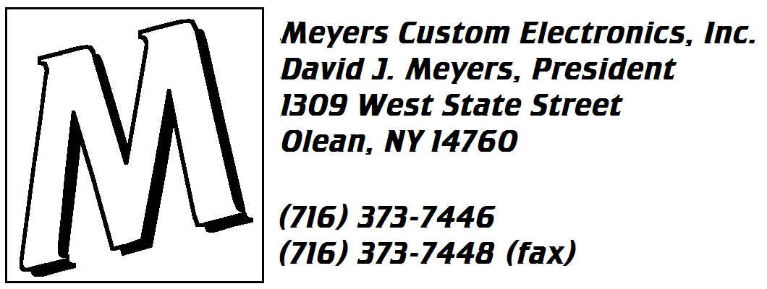
Cabinet Level Display (CLD) User’s Manual
Version 2.0
Note: Highlighted items are new in this version of the manual.
Table of Contents:
System Overview 3
What is the Cabinet Level Display?: 3
Getting the Product Mix Information: 4
Calculating Levels: 4
Manual Adjustments: 4
Automatic Adjustments: 5
Temporary Automatic Adjustments: 5
Stock List Printing: 5
Receipt Printer Routing (Panasonic only): 5
Buffer Engine: 5
Simple Programming: 6
New Menu Item Reminders: 6
Special Considerations: 6
Crew Level Functions 7
Breakfast Cabinet Level Screen 7
Lunch/Dinner Cabinet Level Screen 8
Thawed Item Levels Screen 9
Front Stock Item Levels Screen 10
Grill Stock Item Levels Screen 11
Miscellaneous / Remote Screens 12
Data Screen 1 (Incoming Register Data) 13
Data Screen 2 (Bin / Landing Zone Status) 14
Data Screen 3 (Transaction Trend and Adjustments) 15
Manager Functions 16
Manager Mode Screen 16
Unassigned Menu Items Reminder 17
Cabinet Item Editing Screen 18
Menu Item Assignment Programming 19
Calculation Modes Screen 20
Utilities Screen 21
Panasonic Baud Rate / Printer Assignments Screen 22
Detailed Programming Instructions 23
Initial CLD Setup 23
Install your CLD, using the Cabinet Level Display Installation Manual 23
Connect the full-size keyboard to the CLD 23
Enter Manager, Cabinet Editing, and Quitting Passwords 23
Enter Baud Rate and Printer Assignments (Panasonic 2-plus only) 24
Check the CLD clock, and adjust it, if necessary 24
Make sure your CLD is receiving order data from your POS system 25
Let the CLD learn your menu item names 25
Program the Cabinet Level Screens 26
Programming Examples: 27
Troubleshooting Guide: 30

System Overview

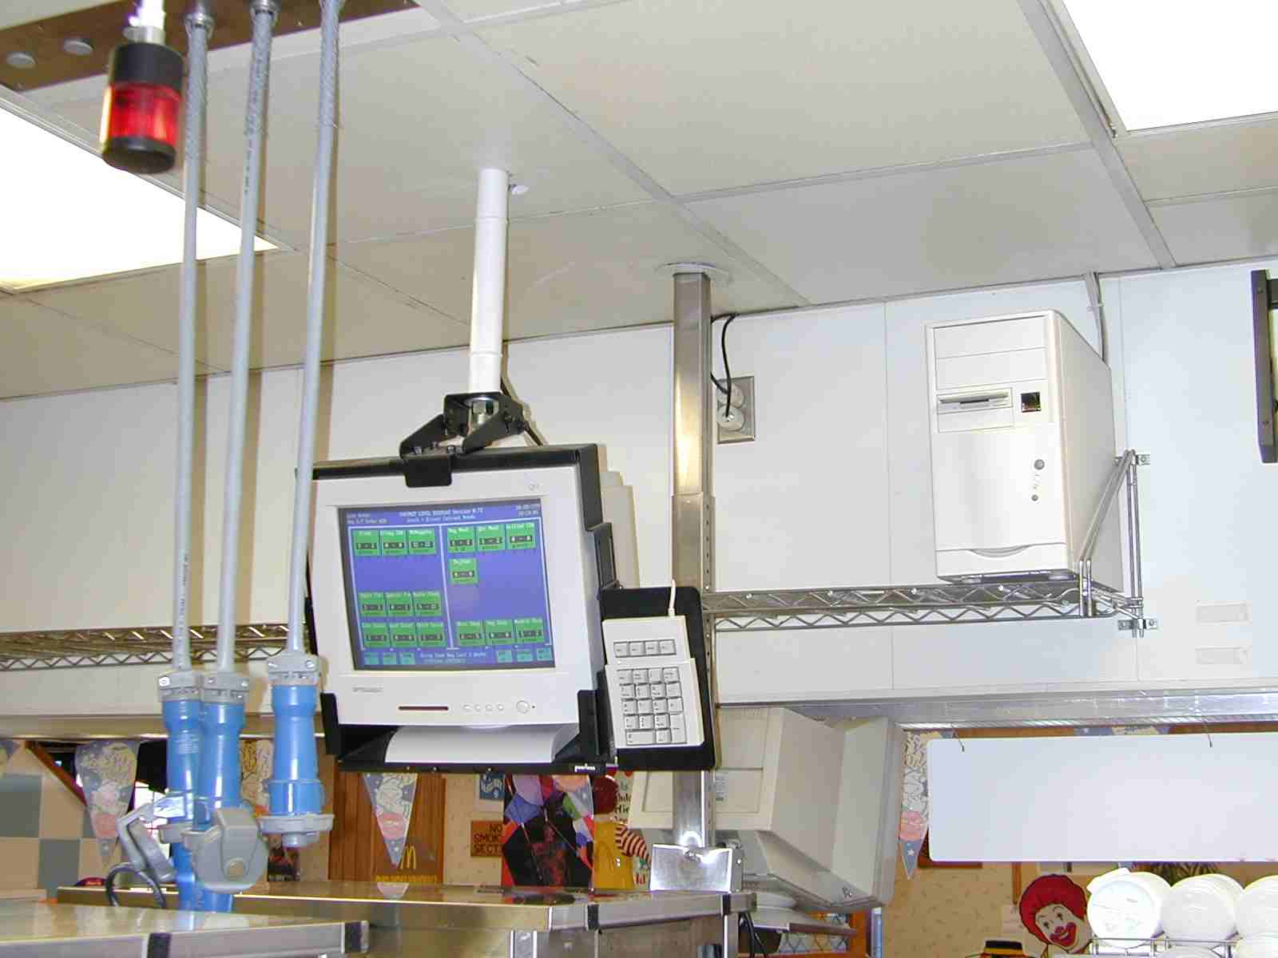

What is the Cabinet Level Display?:
The Cabinet Level Display helps restaurant managers improve customer service, reduce waste, and improve quality. How does it do this? It keeps track of what you sell, and when you sell it. With that information, it can tell the managers and crew what products they need at any particular time of day. This includes holding cabinet items, thawed items, fries, and even stock items. It eliminates a huge amount of manual calculations for the managers. It is like recalculating your product level charts every 5 minutes!
Can you really predict what the customer is going to buy? Not exactly, but our sales patterns are pretty repetitive. Ask any veteran counter person, and they can tell you when a regular customer will arrive and what they will buy. Furthermore, we tend to sell more of our products at certain times of the day than other times. For example, we sell more grilled chicken sandwiches during lunch than at 2:00 in the afternoon. If we average the day's needs over the entire day, we will always run out during lunch. The key is to track not only what we sell, but how many, and when.
With the CLD, a personal computer is installed either in the grill area or in the office. A VGA screen is mounted above the UHC cabinet in the same kind of hanger used for KVS monitors. All components are off-the-shelf items, including a numeric keypad for operator use.

Getting the Product Mix Information:
PC-POS Registers:
The CLD is connected to a PC-POS register, with the exception of a Drive-Thru cashier. You can install the computer yourself, connect it to any register that isn’t already connected to a KVS monitor or COD, and then configure the register so that it sends KVS data to a PARK/SERVE KVS monitor.
Panasonic 2+ Registers:
The CLD is connected just like a printer. Therefore, it can be connected directly to a register on the newer plastic registers. On older stainless steel registers, a printer interface box must be obtained from Panasonic. Once it is connected, you simply must configure the system to send pick lists for each order to this “printer”.
Once connected, you can view the order data on the CLD screen by pressing the [8] key. As you watch, you will see register and order numbers tracked. This means the CLD is learning your menu item names, and counting how many of them you sell. The system breaks the day up into 288 separate 5-minute intervals, and tracks how many of each menu item you sell during that 5-minute interval. Since it tracks things by menu item name, you can decide at any time to add a cabinet item, even if it hadn't occurred to you to do so earlier. The CLD saves this information for 1000 days, and has room for 1000 menu items.

Calculating Levels:
Since the CLD knows what you sell during every 5-minute period of the day, it can tell you what you will probably sell during the next 15, 20, or 30 minutes. As an example, suppose it is now 11:47 and you want to see how many meat patties you need in the cabinet. They have a holding time of 20 minutes. The CLD looks at how many patties you normally sell during the periods ending at 11:55, 12:00, 12:05, and 12:10. It adds them up, and displays the total as a build-to. It will be displayed as pieces or trays, depending on how many you need. You can choose to base your calculations on the previous 1, 2, or 3 days; the previous 1, 2, or 3 weeks; or even 3 specific dates within the last 1000 days. Most of the time, though, you will want the CLD to read in the information from the last 3 weeks and analyze the trend.
Sometimes the manager may want to see where the numbers are coming from. Pressing the [/] key will display the amount of an item sold during each of the 3 days you are basing your levels on. The numbers appear in yellow, above each cabinet level. You can see if the sales are increasing or decreasing, and it makes it a little easier to understand where the displayed levels are coming from.

Manual Adjustments:
There are times when you will want to adjust the cabinet levels displayed. At the start of a Big Mac promotion, for example, you might want to adjust your Regular Meat by 200%, and adjust your Quarter Meat by 80%. You only have to do this for the first day, though, because for the rest of the week you can pull from "yesterday". Is today a special day? Is there a festival in town? How about a blizzard? In those cases, you can globally increase or decrease all cabinet levels from 5% to 995% by entering Manager Mode and pressing the + and - keys. These adjustments appear on the screen in yellow as percents, such as “200%”.

Automatic Adjustments:
Since the CLD system saves every transaction to disk, it is also able to keep track of your hourly transactions on the days you are pulling from, and today’s transactions. With this information, the CLD can automatically reduce or increase the displayed levels to match how today’s transactions compare to the trend. The adjustment the CLD is currently using is displayed in the bottom right corner of the screen. The detailed transaction information can be viewed on the third page of the data screen. Simply press the [8] key, and then press [Enter] twice. If the last 3 hour’s transaction total is less than the trend, then the levels are reduced by that amount. In the case of a transaction rate increase, however, the entire day must have an increase before levels are increased. This makes sure a single bus doesn’t cause you to over-produce your cabinet products.

Temporary Automatic Adjustments:
The system also has the ability to adjust for what is currently selling. For example, if you are selling more of a product than usual, the CLD will adjust its levels to reflect what is actually selling. In order to avoid over-producing, these temporary adjustments will disappear if sales go back to normal. This feature not only helps during buses, it builds credibility with the crew. These adjustments appear on the screen in yellow with plus signs, such as “+2”. This means the level shown in 2 greater than what you normally would need at this time of day.

Stock List Printing:
The PC-POS version of the CLD includes the cables and automatic switch box that allow the POS and the CLD to share your grill printer. This allows your employees to easily print stock lists based on the currently viewed screen. If they want a grill area stock list, they simply have to display the grill stock levels screen, and press the [*/PrtSc] key. The Panasonic version also has this capability, but it requires the purchase of a dedicated CLD printer.

Receipt Printer Routing (Panasonic only):
The CLD connects to a Panasonic-2 system by pretending it is a printer. This allows the CLD to use one connection to the keystation (either an AUX port or an interface box) for both the CLD and an inexpensive printer. The CLD, in fact, can route receipts to 4 different printers, if needed. This can save you a great deal of money, and reduces traffic on your POS network. Printer #1 is also used for your stock list printing.
To configure this option, go into Manager Mode by pressing [8], enter the Manager password (usually 12345), choose Utilities by pressing [8], enter the Editing password (usually your store number), and press [6], “Change POS Baud Rate and/or Printer Assignments.”

Buffer Engine:
The CLD includes a buffer engine that truly anticipates your product needs, just like it does for all of your cabinet and stock items. It communicates to your grill crew using the same printer it uses to print stock lists. It prints a slip whenever you need to MAKE, IGNORE, or WASTE a buffered sandwich. The CLD can track up to 48 simultaneous buffered items, with up to 20 of each in the buffer. You can view the items currently in the buffer, as well as the remaining time for each item, on the second data display screen. Press the [8] key, then press the [Enter] key. When done, press the [Enter] key two more times to exit.
The buffering function can be turned on and off depending on your needs, by pressing the [.] key. The buffered items on the screen will display in orange when buffer printing is enabled.
A buffer item is created by placing it on the Breakfast or Lunch/Dinner screen, and entering “BUFFER” in the Units field.

Simple Programming:
The system is very powerful, but programming it is much simpler than creating a chart or programming the CLS system on the ISP. Connect the full-size keyboard (included) to the connector conveniently located at the CLD screen. Then, follow the menus and the screen images in this manual to program the system. If you have more than one store with identical menu item names, you can copy the information onto a diskette and copy it to additional restaurants. This option is located on the Utilities menu.

New Menu Item Reminders:
In order to assist you in keeping its programming up-to-date, the CLD notifies you whenever new menu items become active on the POS, but haven’t yet been assigned to a CLD cabinet or stock item. An alert screen appears shortly before lunch for the first 7 days a menu item is active. A list of unassigned items is also displayed every time you enter Manager Mode.
Some items (like condiments) will never be assigned. To prevent these items from being flagged each time, you can assign them to a “hidden” cabinet item. A hidden item is created by placing it on any screen (like MISC1 or MISC2) and entering “HIDDEN” in the Units field.

Special Considerations:
If you change the 14-character menu item name on your POS, remember that it will change for the CLD too. For example, if you change your Big Mac Extra Value Meal from EVM-MAC/LRG to EVM-MAC/MED, you will just have to assign the cabinet items to both of these menu items. Tell the CLD that you use 2 regular patties for each of them. Since you didn't sell both on the same day, adding them together will hurt nothing. After 1000 days, the old one will just disappear.
The CLD starts and ends its sales day at 4:00 AM. At that time, the system restarts and loads the new day’s product mix information. The CLD is successfully being used in 24-hour restaurants. Just be aware that as the time approaches 4:00, the system will only tell you what you need in the cabinets between that time and 4:00. After 4:00, everything will return to normal.
There is an issue in Store Systems 1.5, which affects the CLD. When you connect the CLD to a front counter register, orders taken on that particular register will not serve off of the CLD. This is due to a change in the PC-POS software, and the same problem exists with KVS monitors without bump bars. The CLD programming now is able to bump orders off the register in these cases, provided you use a new “bi-directional” CLD cable. If you are upgrading your registers to SS 1.5 and need to swap cables please contact Meyers Custom Electronics.

Crew Level Functions

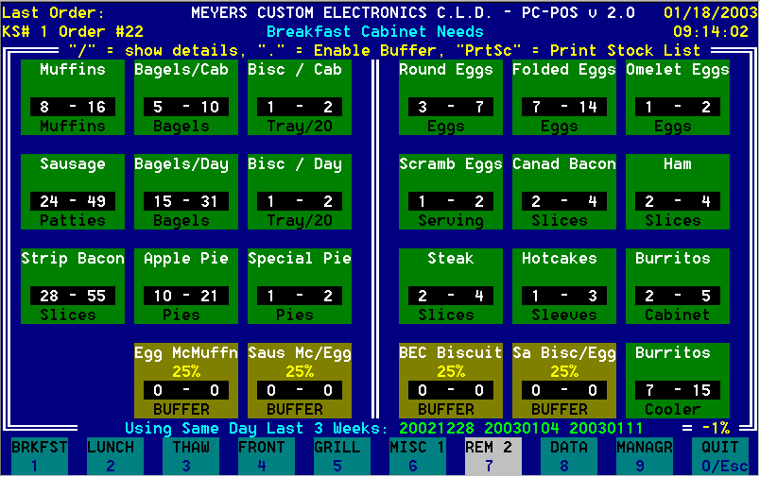
Breakfast Cabinet Level Screen

Breakfast Cabinet Level Screen
This screen is displayed by pressing the [1] key on the keypad, and is normally displayed throughout the breakfast period. Grill crew simply need to look at the screen to determine what they need in their cabinet.
To encourage batch-cooking, the levels are displayed as a LOW-HIGH range. When the cabinet level drops below the LOW quantity, a crewperson just needs to batch-cook enough to get back to the HIGH quantity.
In this example, there are 4 BUFFER menu items in the bottom row. They are adjusted to 25%, which is a reasonable compromise between service and waste. This means that 1 in 4 sandwiches should already be in the landing zone when they are ordered. With a 5 minute holding time, you could never expect to achieve 100% without excessive waste. The BUFFER items are displayed in orange, indicating that buffer printing has been turned on. Press [.] to turn it off.
As customer orders are captured by the CLD, their register and order numbers appear in the top left corner of each screen. This way, you can always be assured that the CLD system is recording all transactions. If this doesn’t change, or a “NO REGISTER DATA IN LAST 9 MINUTES” message appears, you may have to check the cables and/or restart the CLD system or the register it is connected to.

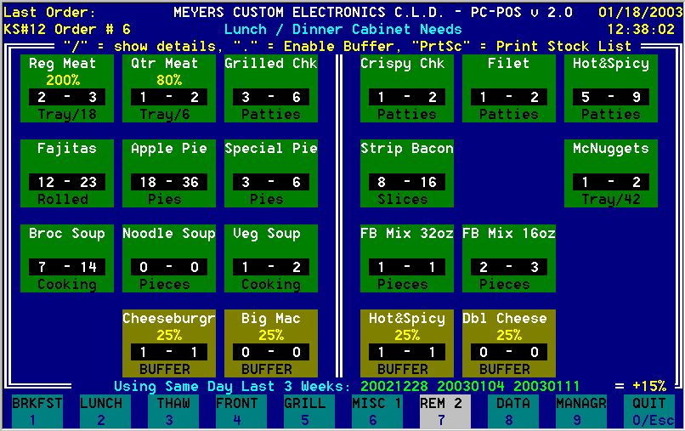
Lunch/Dinner Cabinet Level Screen (with adjustments)

Lunch/Dinner Cabinet Level Screen
This screen appears when the [2] key is pressed. It updates every 5 minutes, and tells the crew how many lunch or dinner items to keep in the cabinets. Note that in this example, Regular Meat and Quarter Meat have been adjusted for the start of a Big Mac promotion. Regular Meat needs are doubled, and Quarter Meat needs are reduced by 20%.
Although you tell the system how many items there are per tray, you wouldn't want the system to round up to 1 tray during a slow period. Therefore, if the calculated need is less that 1½ full trays, the cabinet level will be displayed in pieces instead of trays.
At the bottom of the screen, the current calculation mode is displayed, as well as the 1-3 dates which are being used for level calculations. If data from that date is available, the date appears in green. If that date is missing, the date will appear in red.
In the bottom right corner, you can see that transactions for the day are up 15%, and the CLD has adjusted all of the levels accordingly. If you want to override this feature, you can enter Manager Mode, and press the [+] key once to enter a manual adjustment of +1%.
As in the breakfast example, there are 4 BUFFER menu items in the bottom row. Once again, they are displayed in orange (which looks red on some monitors,) indicating that buffer printing has been turned on. Press [.] to turn it off.

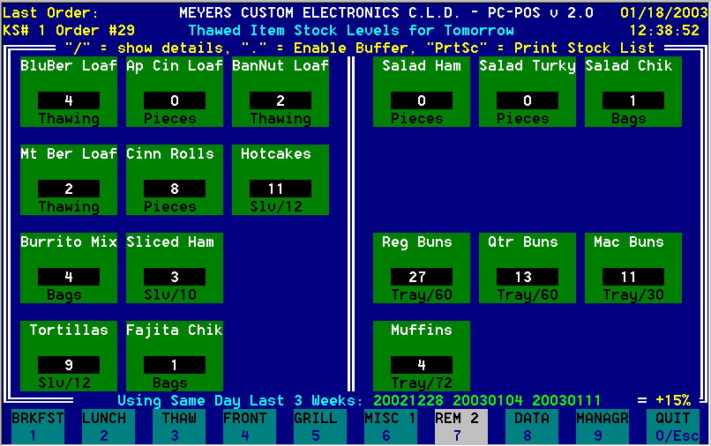
Thawed Item Levels Screen

Thawed Item Levels Screen
This screen is displayed only on demand, usually in the evening. The Crewperson simply needs to press the [3] key. This screen displays the number of thawed items to pull tonight for what the restaurant will sell during each product's secondary shelf life. Unlike other methods, however, it takes into account the actual days of the week involved. This screen was captured on a Saturday. On the bottom, you can see that the previous 3 Saturdays are in the database. What you don't see is that it also has the last 3 Sundays, Mondays, Tuesdays, Wednesdays, Thursdays, and Fridays in its database. If a product has a holding time of 2 days, The CLD will add the trend of the last 3 Sundays with the trend of the last 3 Mondays. This is much more accurate than just doubling Sunday’s needs, which is essentially what existing tools do.
In order to reduce waste, levels on the thawed item screen are automatically reduced by 25%. If an item has a shelf life of 4 days, for example, the level on the thawed item screen will be sufficient for 3 days. Stocking for the full shelf life would guarantee waste.

The bottom right corner indicates that transactions today are up 15%. However, the thawed item screen does not automatically adjust levels. This is because it projects levels for tomorrow and future days, not today.

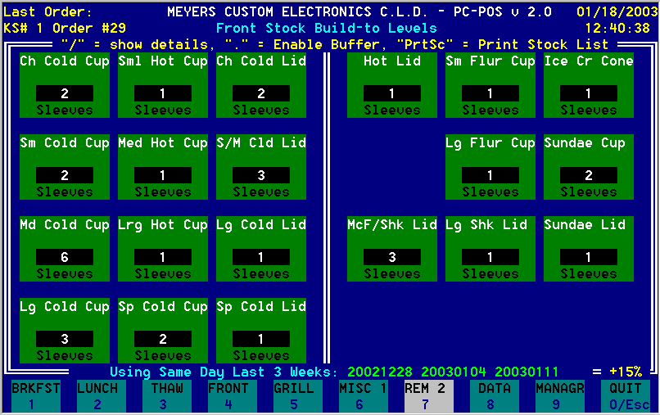
Front Stock Item Levels Screen

Front Stock Item Levels Screen
This screen works just like the Breakfast and Lunch screens. When you press the [4] key, you can see how many front stock items you will need for the rest of the day. Simply set the holding time to 1440 (24 hours) for paper items, and you will be able to bring up just enough stock for the rest of the day.
It is amazing how much room you will save by only bringing one day’s supply from the stock room.
For this to work properly, paper items should be stocked in the morning.
If you have connected your grill printer to the CLD, you can print a build-to stock list by pressing the [*/PrtSc] key.

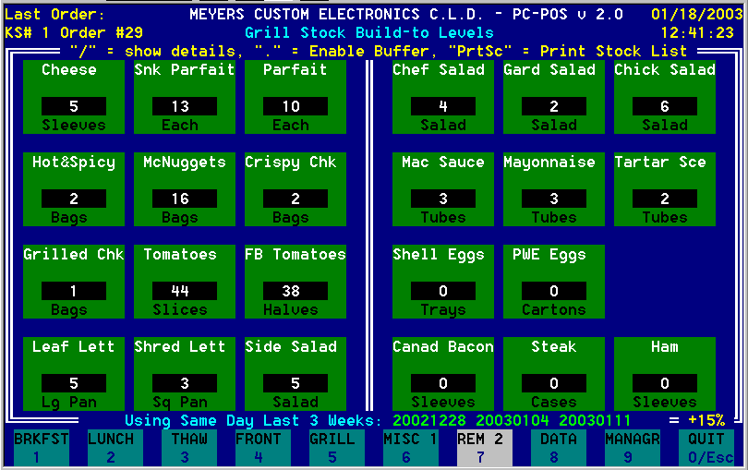
Grill Stock Item Levels Screen

Grill Stock Item Levels Screen
Like the Front Stock screen, this screen is displayed by pressing the “5” key. This screen displays the build-to for grill stock items, and helps make sure you have the proper amount of stock. No longer is it necessary to complete a stock list by hand. Simply compare the levels on the screen with the stock on hand, and bring up what is needed. Paper stock items can be given a 1440 minute holding time (1 day), and food items can be given holding times based on company standards.
If you have connected your grill printer to the CLD, you can print a build-to stock list by pressing the [*/PrtSc] key.

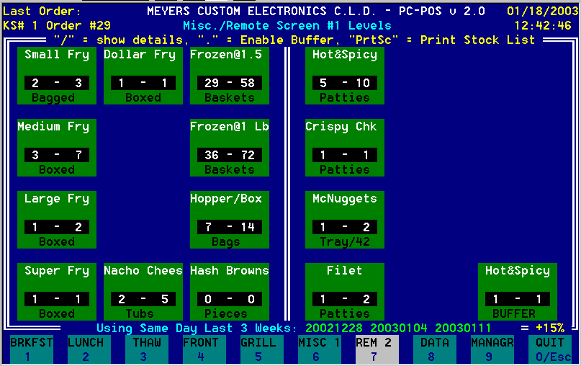
Miscellaneous / Remote Screen

Miscellaneous / Remote Screens
Screens 6 and 7 can be used exactly the same way as the Breakfast, Lunch, Grill Stock, and Front Stock screens. They can be used for any cabinet or stock items, but not for thawed items, because they only look at the current day’s needs.
These screens also have another purpose. You can purchase an additional Wyse WY-55 monitor (the same kind you use for your KVS monitor) and display monochrome versions of these screens remotely. The screen shown is a good example. A remote screen is located at the fry station, and displays fry station and fried product needs at all times. Programming, however, is still done at the CLD system.
The CLD system constantly scans its ports. If a screen is detected, the key label at the bottom of the screen changes from “MISC” to “REM” to indicate the presence of a remote screen.

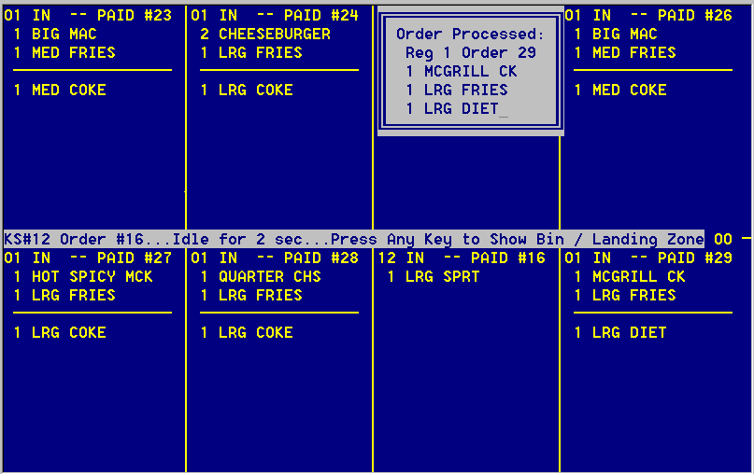
Data Screen 1 (Incoming Register Data)

Data Screen 1 (Incoming Register Data)
This screen is used mainly for initial installation and troubleshooting purposes. Since the POS system sends register data to the CLD, you need a way of ensuring that data is indeed being received by the CLD system. This particular screen in from a PC-POS system. On the center line, you can see that the system last processed Register #1's Order #24. This occurs as soon as the order's status changes from TOTAL to PAID. If you see the orders being captured, you know the system is working properly.
When an order is captured, the CLD shows its interpretation of the contents of that order. In this example, the CLD just processed order 29 from register 1. This box will only appear for a few seconds after the order becomes “PAID.”
If you have a Panasonic system, the DATA screen will be slightly different. Instead of looking like a KVS monitor, the left half of the screen will look like a register tape. As the “tape” scrolls up, the right half of the screen will display the register number, order number, and menu items processed.
Whenever the CLD indicates a communication problem, you should first check this screen.
When you are finished with this screen, press the [Enter] key to move on to Data Screen 2, Data Screen 3, or back to the cabinet level screen.

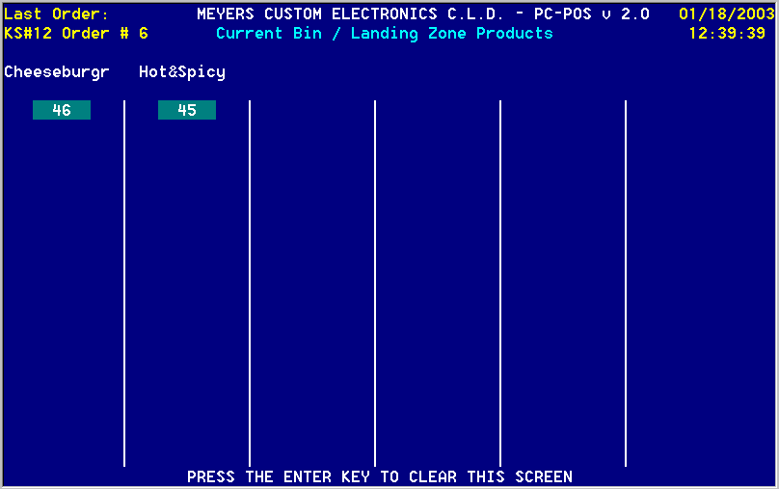
Data Screen 2 (Bin / Landing Zone Buffer Status)

Data Screen 2 (Bin / Landing Zone Status)
This screen shows the current status of your completed products buffer. If you have not enabled your buffer (by pressing the [.] key) or if levels are zero, this screen will be blank.
A buffer item is created by placing it on the Breakfast or Lunch/Dinner screen, and entering “BUFFER” in the Units field. Even though this screen can only display the first 6 buffer items, the CLD can track up to 48 different products with up to 20 of each in the buffer.
This screen is analogous to a slanted holding bin with slides. The customer would be at the top of the screen. In this example, there are two sandwiches in the buffer, and they expire in 46 and 45 seconds. As products are added to the buffer, they will be added to the bottom of each column. As buffer sandwiches are sold, you will see the holding times shift up, to reflect the movement of the sandwiches.
As this is happening, the crew are receiving instructions on their shared grill printer:
*** CLD BUFFER *** 12:45 / MAKE <qty> <item> / New Level = <level>:
Instructs the crew to make a sandwich for the buffer.
*** CLD BUFFER *** 12:48 / IGNORE NEXT <qty> <item> / New Level = <level>:
Your buffer needs have decreased, but buffer sandwiches have not expired.
*** CLD BUFFER *** 12:50 / WASTE <qty> <item> / New Level = <level>:
Waste the first product of that type in the buffer.
When you are finished with this screen, press the [Enter] key to move on to Data Screen 3, or back to the cabinet level screen.
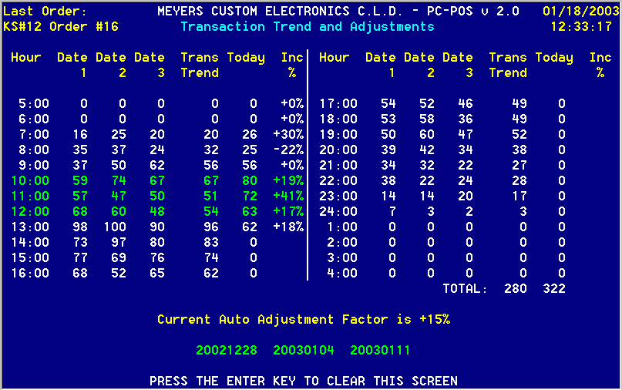
Data Screen 3 (Transaction Trend and Adjustments)

Data Screen 3 (Transaction Trend and Adjustments)
This screen displays the data the CLD uses to automatically adjust your levels based on today’s actual transactions. Dates 1, 2, and 3 are the 3 dates you are pulling product mix from, and are displayed at the bottom of the screen. The transaction trend is calculated using the same rules as your cabinet levels. This example shows actual numbers from a restaurant on the Saturday of a holiday weekend.
First, the CLD looks at how your transactions during the last 3 hours compare with the trend. If they are below the trend, the CLD would automatically adjust down, in case the weather took a turn for the worse.
In this example, however, those 3 hours show an increase. In the case of an increase, the CLD compares the entire day’s transactions (through the last complete hour) with the trend. The adjustment factor is therefore 322 / 280 or +15%.
When you are finished with this screen, press the [Enter] key to go back to the cabinet level screen.

Manager Functions

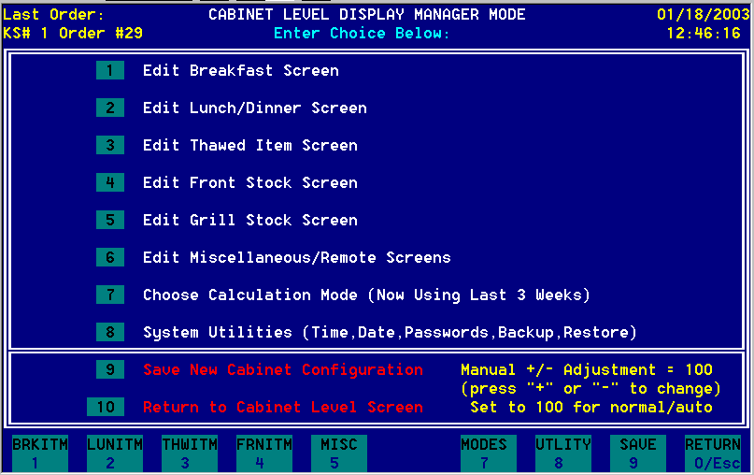
Manager Mode Screen

Manager Mode Screen
This screen is accessed by pressing [9] on the keypad, then entering the manager password. The Restaurant Manager uses this screen to set up the cabinet items they want to display, and tell the CLD which menu items use these cabinet items.
A supervisor password is needed to access all of these items except for changing the calculation mode, so you can allow certain managers to just perform that function. This is useful if you want to pull from yesterday's product at the start of a promotion, but use last week's information after the first week is recorded.

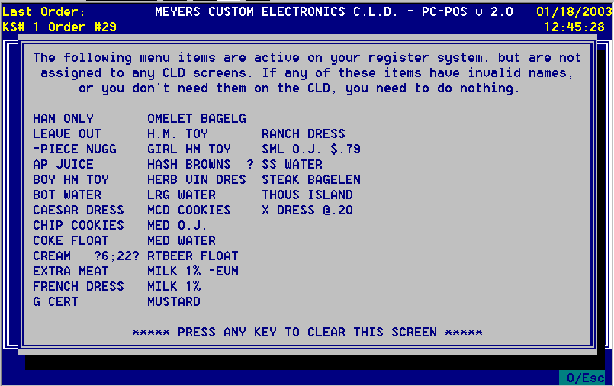
Unassigned Menu Items Reminder

Unassigned Menu Items Reminder
This notice appears whenever you enter Manager Mode, provided you have at least one menu item that has not been assigned to a CLD cabinet item. It also appears once a day, just prior to lunch, for the first 7 days a menu item appears. This helps you remember to add new menu items to your CLD setup.
This screen was captured on a test POS system that was frequently rebooted, disconnected, and reconnected. Because of this, there are a few “garbage” names (such as CREAM ?6;22?.) This is fairly common when you have power failures and POS problems. These items can be safely ignored, and they will disappear if not seen again in 7 days.
Some items (like condiments) will never be assigned. To prevent these items from being flagged each time, you can assign them to a “hidden” cabinet item. A hidden item is created by placing it on any screen (such as MISC1 or MISC2) and entering “HIDDEN” in the Units field.
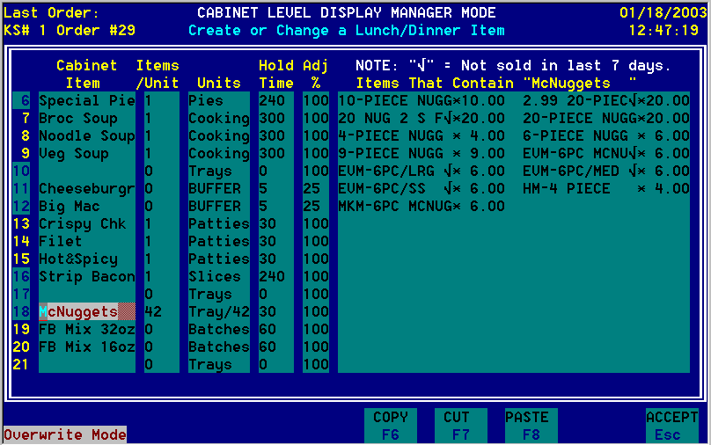
Cabinet Item Editing Screen

Cabinet Item Editing Screen
As everyone knows, if a system isn't easy to use, it will not be used. A great deal of care was taken in order to make it easy for Managers and Owner/Operators to program their systems.
For each item, you need to enter a name, items/unit, units (tray, bag, etc), holding time (or days for thawed items), the adjustment factor (usually 100%), and the menu items which contain the item. Here, the menu items which contain McNuggets are displayed. It is obvious that you assign 6 McNuggets to a 6-PIECE, and so on.
All fields can be edited as you would expect, with full usage of keyboard keys for editing. Since both Insert and Overwrite modes are supported (by toggling the Insert key), you don't need to re-enter an entire name to correct an error. You must, however, connect the full-size keyboard in order to enter any letters. You can also copy, delete, or move cabinet items if you position the cursor on the item name and use the appropriate COPY/CUT/PASTE function keys shown at the bottom.
Since it is normal to frequently add and remove similar items, the CLD flags items that are not currently being used. Those items that haven’t been rung up in the last 7 days appear with a check mark after their name.
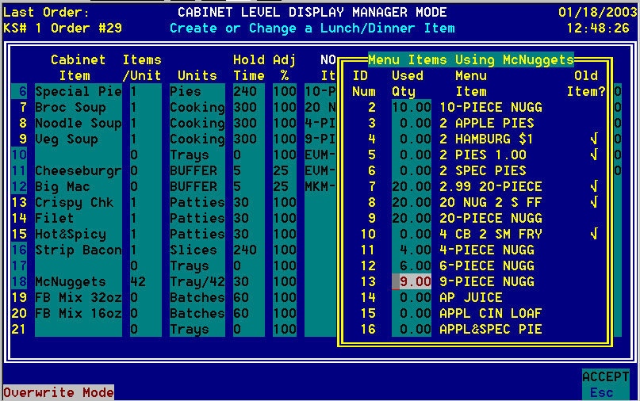
Menu Item Assignment

Menu Item Assignment Programming
With this system, there is no need to enter menu item names. Simply start selling a new menu item, and the system will add it to its list automatically. After you have sold at least one, you can then assign it to the proper cabinet items.
On the editing screen, just tab over to the menu items area. A box will then pop-up displaying the first 15 menu items, and the number of the current cabinet item you need for each item. The menu item list is in alphabetical order. The “ID Num” shown is not significant. It merely gives you an idea of where you are in the list.
Any number from –99.99 to 99.99 is an acceptable quantity. For example, you use 0.5 cheese slices on a Filet-o-Fish, and you use 20.00 McNuggets in a 20-Piece.
There will be some cases when you will need a negative usage number. A good example is the French Fries (MISC1) screen. When you Super-Size an Extra Value Meal (on some POS systems), you will need to call for 1 Super-Sized Fry, but –1 Medium Fry. This is because the recipe for the meal already includes one medium fry box. This will avoid over-producing Medium Fries.
Once again, items that haven’t been used in the last 7 days are flagged with a check mark. These items will disappear if you remove all references to them in your cabinet programming.
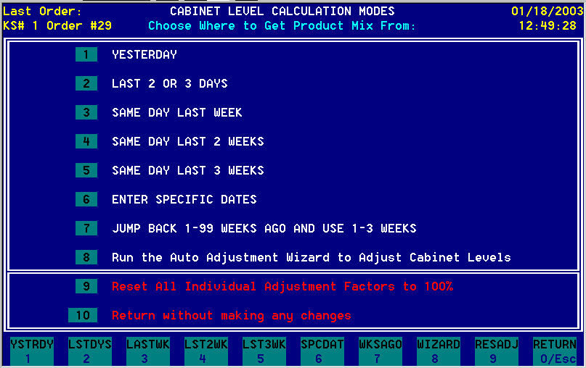
Calculation Modes Screen

Calculation Modes Screen
This is where you tell the CLD system how to calculate the levels you need.
- Use the product mix from yesterday: This is used when you have just started (or ended) a promotion within the last 6 days. Since you cannot yet pull information from the previous week, this is a useful calculation method. Alternatively, if a promotion just ended, you could just enter three specific dates from before the promotion started (see below).
- Use the product mix from the last 2 or 3 days: When you make this choice, another box will appear, asking you if you want to use the last 2 or 3 days. Press [2] for 2 and [3] for 3.
- Use the product mix from same day last week: If today is Wednesday, this will take the actual product mix from last Wednesday.
- Average the product mixes from the same day in the last 2 weeks: If today is Wednesday, this will take the actual product mix from the last two Wednesdays and average them.
- Compute the trend based on the same day in the last 3 weeks: This will calculate the levels based on each of the last 3 weeks, and calculate the result based on the trend.
- Compute the trend based on up to 3 specific dates: This is just like the previous method, only you get to enter 3 specific dates. Are you starting McRib tomorrow? If you sold it within the last 1000 days, you can just enter the first day (or 2 days, or 3 days) of the last time you sold it.
- Jump Back 1-99 Weeks and use 1-3 Weeks: This is useful if you just completed a promotion and want to go back to what your product mix was before the promotion started.
- Run the Auto Adjustment Wizard to Adjust Cabinet Levels: This will adjust all of your cabinet items based on the actual impact a new promotion has had on them. The wizard will ask you how many weeks ago you want to use for the “before” sample, and how many days ago you want to use for the “after” sample. After you run the wizard, you can manually edit the adjustments for each screen before saving them.
- Reset All Individual Adjustment Factors to 100%: This simply resets all adjustments to 100% if you decide to start over.
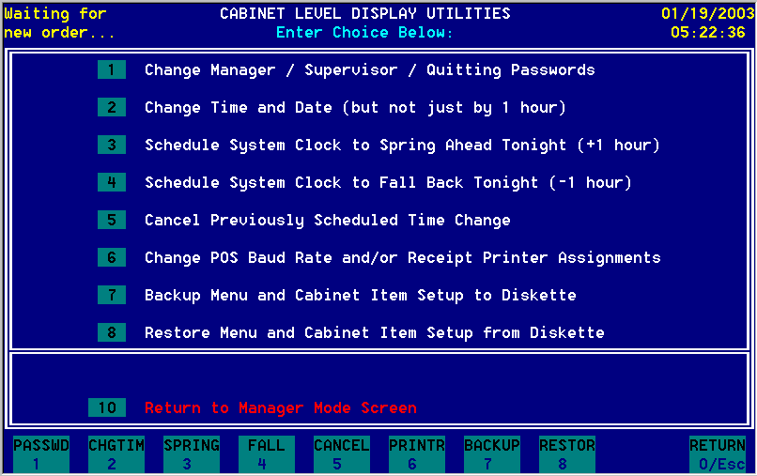
Utilities Screen (Panasonic version)

Utilities Screen
This screen is used for miscellaneous functions, and is pretty self-explanatory.
You reach this menu by pressing the [8] key on the Manager mode menu. You will need to enter the Editing password, which is usually your store number.
Options 3 and 4 are quite popular. Anytime on the Saturday before the time change, the manager simply chooses to “spring ahead” or “fall back” that night. After that is fully automatic, and the time will change at 2:00 AM. A message will appear for the rest of the day, reminding the crew of the pending time change.
Option #6 only exists on Panasonic 2-plus systems.
Option #7 is used to back up all of the programming you have done, but does not back up your product mix. To back up your product mix, you must exit all of the way out of the CLD program and choose the “SAVE” option.
Option #8 is used to reload the programming you previously saved to diskette. It can also be used to copy another restaurant’s layout. Simply “backup” at one restaurant, and “restore” at another. This only works, however, if both stores use the same menu item names.
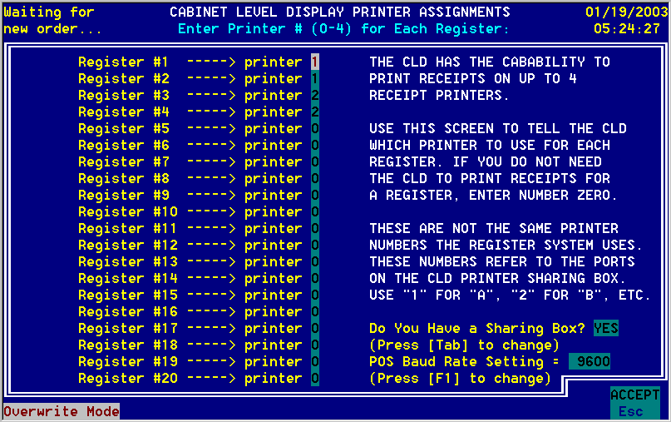
Panasonic Baud Rate / Printer Assignments Screen

Panasonic Baud Rate / Printer Assignments Screen
This screen only exists on Panasonic 2-plus systems.
You reach this menu by pressing the [6] key on the Utilities menu.
Baud Rate:
The first function of this screen is to set your Baud rate. This is the communication rate the POS uses to send the orders to the CLD. Since the CLD pretends it is a printer, this must match the printer baud rate on your register.
In general, this should be 4800 for Plastic registers and 9600 for stainless steel interface boxes. Simply press the [F1] key until it is correct.
Receipt Printer Routing:
The second function is to assign receipt printers to registers, if you have installed the 4-printer sharing box on your system. This box is an “Aten AS-154P Bi-Directional 1 to 4 Parallel Auto Switch,” and costs about $7.00.
Press [Tab] to tell the CLD you have a box. Then, choose which register will print receipts to which printer. Stock lists and buffer slips will always print to printer 1.
In this example, registers 1 and 2 will print to printer 1 (connected to port A of the box), and registers 3 and 4 will print to printer 2 (connected to port B of the box).
Press [Esc] to save your changes and exit the screen.

Detailed Programming Instructions

Initial CLD Setup

Install your CLD, using the Cabinet Level Display Installation Manual
The installation manual is shipped with each system. If you have misplaced yours, you can download a replacement at http://www.webmce.com/cld_downloads.html.

Connect the full-size keyboard to the CLD
There is a keyboard connector attached to your CLD monitor bracket, right behind the keypad bracket. Simply plug your keyboard cable into this connector. If the “Num Lock” light is not lit, press the “Num Lock” key.

Enter Manager, Cabinet Editing, and Quitting Passwords
Your CLD is shipped with all passwords cleared. In order to prevent unauthorized access, you should change them as soon as you power up your CLD system. The Manager password is usually set to “12345”, and the Cabinet Editing and Quitting Passwords are usually set to your national store number. Starting at the main Cabinet Level Display screen, do the following:

- Press the “9” key to enter Manager Mode. Since the passwords are cleared, you will not be prompted to enter a password.
- Press the “8” key to select the Utilities Menu.
- Press the “1” key to select the Change Passwords function.
- When prompted, enter each password. You will be asked to re-enter each password to ensure accuracy.
- You will return to the Utilities screen.
- If you do NOT have Panasonic 2-plus registers, escape back out to the main CLD screen by pressing the [Esc] key two times.

Enter Baud Rate and Printer Assignments (Panasonic 2-plus only)
You must tell the CLD what baud rate the POS is using to send receipts to the CLD. If you have the 1 to 4 printer-sharing box, you must also tell the CLD which registers will print on which printer:

- Press the “9” key to enter Manager Mode, if necessary.
- Press the “8” key to select the Utilities Menu, if necessary.
- Press the “6” key to select the Change POS Baud Rate and/or Receipt Printer Assignments function.
- Press the [F1] key to choose your baud rate. Use 4800 for plastic registers and 9600 if you have a stainless steel printer interface box.
- Press the [Tab] key to tell the CLD if you have a printer-sharing box.
- If you have a sharing box, enter the receipt printer number for each register. For example, to have register 1 print to printer 2, enter “2” next to “Register #1 →.” The ports on the box are labeled with letters, so A=1, B=2, D=3, and E=4. It sounds confusing, but C=Common, which is where the printer connects to.
- Press “ESC” three times to save and escape all the way back to the main CLD screen.

Check the CLD clock, and adjust it, if necessary
Look at the time and date displayed in the top right corner of the CLD screen. If it does not match the clock on your POS system, you need to set the clock. Starting at the main Cabinet Level Display screen, do the following:

- Press the “9” key to enter Manager Mode. When you are asked for the Manager Password, enter it (usually “12345”.)
- Press the “8” key to select the Utilities Menu. When you are asked for the Cabinet Editing password, enter it (usually the national store number.)
- Press the “2” key to select the Change Time and Date function.
- The next screen will sternly warn you that incorrectly entering the time and date will cause product mix information to be deleted. Since the CLD has no information yet, simply press the “9” key to continue.
- Carefully follow the screen instructions to enter the date and time. If the date is already correct, just press the Enter key to continue.
- Press the “9” key to change the time and date to your new settings, or press the “ESC” key to cancel.
- When you press the “9” key, the CLD will restart.

Make sure your CLD is receiving order data from your POS system
The CLD incorporates a Data Display mode to allow you to see if the CLD is receiving order information from the POS system. If you have a PC-POS system, the screen will look just like a KVS monitor. If you have a Panasonic POS system, the screen will look like a register tape scrolling up the left side, and the menu items appearing on the right side. Simply look at the screen and make sure all registers are sending orders to the CLD. If they are not, refer to the Troubleshooting Guide later in this manual. Starting at the main Cabinet Level Display screen, do the following:

- Press the “8” key to enter Data Display Mode.
- The Data Display screen will now appear. View several orders, to make sure orders appear correctly. In addition, make sure the Register Number and Order Number are updated as the orders are PAID.
- Press the “Enter” key three times to return to the main Cabinet Level Display screen.

Let the CLD learn your menu item names
At this point, the initial CLD setup is complete. Now, you need to wait until the CLD learns the names of all of your menu items. To so this, you simply have to let the CLD run for one full day. The CLD will automatically learn your menu item names while it saves your product mix information to its hard drive.

Program the Cabinet Level Screens
After the CLD has had time to learn your menu item names, you can complete the programming of the actual cabinet level screens. Several tables of programming examples are provided in the “Programming Examples” section of this manual. The example here is for the Breakfast screen, but the procedure is similar for the other screens. Remember that until you press the “9” key (SAVE) on the Manager Mode screen, your changes have not been recorded to disk. SAVE YOUR CHANGES OFTEN! Starting at the main Cabinet Level Display screen, do the following:

- Press the “9” key to enter Manager Mode. When you are asked for the Manager Password, enter it (usually “12345”.)
- Press the “1” key to select “Edit Breakfast Screen.”
- The “Create or Change a Breakfast Item” screen will appear. The first cabinet item name will be highlighted. In this example, we will use “Muffins.” If you are satisfied with the name, press the “Tab” key to move right to the “Items/Unit” column.
- The “Items/Unit” column goes along with the “Units” column. Let’s use muffins as an example. If you normally put 6 muffins in a cabinet tray, then you would set “Items/Unit” to 6. Press the “Tab” key to move right to the “Units” column.
- Enter the units for this cabinet item. In the muffin example above, you would enter “Trays” here. If you don’t have a standard number of items you put in a tray, you should enter “1” in the “Items/Unit” column and a meaningful name in the “Units” column, such as “Muffins” or “Toasted.” Press the “Tab” key to move right to the “Hold Time” column.
- Enter the holding time in the “Hold Time” column. This is the holding time of the product, in minutes, from 1 to 1440. On the Thawing Levels screen, however, things are a little different. In that case, the column is labeled “Hold Days” and the number is the holding time in days for thawed items, from 1 to 7. Press the “Tab” key to move right to the “Items that contain…” column.
- As soon as you tab to the next column, a selection box will appear with an alphabetical listing of the menu items the CLD has learned. Arrow up or down (or use PageUp or PageDown keys) until the cursor is on a menu item that contains your cabinet item. Enter the number of the cabinet items in the recipe for each menu item. The best example of this is McNuggets. You would enter 6.00 for a 6-piece, 9.00 for a 9-piece, and 20.00 for a 20-piece order. When you have assigned all applicable menu items to this cabinet item, press the “ESC” key.
- If you want to continue editing other cabinet items, press the Up or Down arrows. If you are done making changes, press “ESC” once. Press the “9” key to save your changes.
- When done editing, press the “ESC” key to return to the main Cabinet Level Display screen.

Programming Examples:

Lunch / Dinner  Cabinet Item | Items  / Unit | Units | Hold  Time | Items That Contain…
McNuggets | 42 | Trays | 30 | 6-PIECE NUG * 6.00  9-PIECE NUG * 9.00  20-PIECE NUG * 20.00  HAPPY NUG * 4.00
Filet | 1 | Portion | 30 | EVM-FILET * 1.00  FILET-O-FISH * 1.00
Crispy Chk | 1 | Patties | 30 | CRISPY CHK * 1.00  EVM-CRISPY CHK * 1.00

Thaw Screen  Thawed Item | Items  / Unit | Units | Hold  Days | Items That Contain…
Cinn Rolls | 16 | Box | 2 | CINNAMON ROLL * 1.00
Hotcakes | 12 | Sleeves | 3 | EVM-HTCK SAUS * 3.00  HOTCAKES ONLY * 3.00  HOTCAKES SAUS * 3.00
Salad Chick | 1 | Bags | 3 | CK CAESAR * 0.08
Salad Ham | 1 | Bags | 3 | CHEF SALAD * 0.08
Salad Turky | 1 | Bags | 3 | CHEF SALAD * 0.08

Front Screen  Stock Item | Items  / Unit | Units | Hold  Time | Items That Contain…
Ch Cold Cup | 100 | Sleeves | 1440 | CHD COKE * 1.00  CHD DIET * 1.00  CHD HI-C * 1.00  CHD ITEA * 1.00  CHD LEM * 1.00  CHD RB * 1.00  CHD SPRT * 1.00  SML O.J. * 1.00
Sundae Lid | 100 | Sleeves | 1440 | CARM SUNDAE * 1.00  FUDGE SUNDAE * 1.00  STRAW SUNDAE * 1.00  VANILLA CUP * 1.00

Grill Screen  Stock Item | Items  / Unit | Units | Hold  Time | Items That Contain…
McNuggets | 42 | Bags | 240 | 6-PIECE NUG * 6.00  9-PIECE NUG * 9.00  20-PIECE NUG * 20.00  HM-4 PIECE * 4.00
Crispy Chk | 18 | Bags | 240 | CRISPY CHK * 1.00  EVM-CRISPY CHK * 1.00
Tomatoes | 1 | Slices | 120 | BIG-N-TASTY * 1.00  BIG-N-TASTY CHS * 1.00  CRISPY CHK * 1.00  EVM-BIG-N-TST * 1.00  EVM-BIGNT CHS * 1.00  EVM-CRISPY CHK * 1.00  EVM-GRILL CHK * 1.00  GRILL CHK * 1.00
Leaf Lett | 20 | Cambros | 120 | BIG-N-TASTY * 2.00  BIG-N-TASTY CHS * 2.00  CRISPY CHK * 2.00  EVM-BIG-N-TST * 2.00  EVM-BIGNT CHS * 2.00  EVM-CRISPY CHK * 2.00  EVM-GRILL CHK * 2.00  GRILL CHK * 2.00
Shred Lett | 16 | Sq Pan | 120 | BIG MAC * 1.00  EVM-BIG MAC * 1.00  EVM-MCCHICKEN * 1.00  MCCHICKEN * 1.00
Mac Sauce | 1 | Tubes | 1440 | BIG MAC * 0.03  EVM-BIG MAC * 0.03
Mayonnaise | 1 | Tubes | 1440 | BIG-N-TASTY * 0.02  BIG-N-TASTY CHS * 0.02  CRISPY CHK * 0.02  EVM-BIG-N-TST * 0.02  EVM-BIGNT CHS * 0.02  EVM-CRISPY CHK * 0.02  EVM-GRILL CHK * 0.02  EVM-MCCHICKEN * 0.02  GRILL CHK * 0.02  MCCHICKEN * 0.02
Tartar Sce | 1 | Tubes | 1440 | FILET-O-FISH * 0.04  EVM-FILET * 0.04

Misc Screen 1  Item | Items  / Unit | Units | Hold  Time | Items That Contain…
Small Fry | 1 | Bagged | 7 | HM-4 PIECE * 1.00  HM-CHSBURGER * 1.00  HM-HAMBURGER * 1.00  MKM-6 PIECE * 1.00  MKM-DBL CHEES * 1.00  MKM-DBL HAMB * 1.00  SML FRIES * 1.00
Medium Fry | 1 | Boxed | 7 | EVM-BIG MAC * 1.00  *** Other EVM’s * 1.00 ***  MED FRY * 1.00  LRG UPCHARGE * -1.00  SS UPCHARGE * -1.00
Large Fry | 1 | Boxed | 7 | LRG FRIES * 1.00  LRG UPCHARGE * 1.00
Super Fry | 1 | Boxed | 7 | SS FRIES * 1.00  SS UPCHARGE * 1.00
Frozen@1.5 | 1 | Baskets | 120 | SML FRIES * 0.16  MED FRIES * 0.32  LRG FRIES * 0.38  SS FRIES * 0.52  *** Happy Meals * 0.16 ***  *** EVM’s * 0.32 ***  LRG UPCHARGE * 0.06  SS UPCHARGE * 0.20
Frozen@1 Lb | 1 | Baskets | 120 | SML FRIES * 0.24  MED FRIES * 0.48  LRG FRIES * 0.56  SS FRIES * 0.80  *** Happy Meals * 0.24 ***  *** EVM’s * 0.48 ***  LRG UPCHARGE * 0.08  SS UPCHARGE * 0.32
Frozen | 1 | Bags | 120 | SML FRIES * 0.04  MED FRIES * 0.08  LRG FRIES * 0.09  SS FRIES * 0.12  *** Happy Meals * 0.04 ***  *** EVM’s * 0.08 ***  LRG UPCHARGE * 0.01  SS UPCHARGE * 0.06

Troubleshooting Guide:

Problem | Cause | Solution
ALL: No orders or gridlines appear on the CLD in data display mode. | ALL: CLD data cable is not connected properly.  ALL: The hardware configuration for the register was not entered correctly.  ALL: Your registers use non-standard hardware settings. | ALL: Make sure the CLD data cable is plugged into the connector with the yellow dot on the CLD computer. Make sure it is connected to the correct COM or option port on the register.  PC-POS: Perform the hardware configuration step (1f) again.  PAN: Check the DIP switches (2a) or option port programming (2b).  ALL: Call your Help Desk and ask them for the correct hardware settings.
ALL: Gridlines and/or orders appear on the CLD in data display mode, but not orders from all registers. | PC-POS: The PARK/SERVE location for some registers was not entered as CLD.  PC-POS: All registers were not rebooted after changes.  PAN: The register was not configured for an Expeditor Printer | PC-POS: Perform step (1h-i) again for the affected registers, and reboot them.  PC-POS: Reboot the affected registers.  PAN: Perform step (2c) on the missing register.
Continued next page…  PC-POS: Orders appear on the CLD in data display mode, but no orders serve off. | PC-POS: The Bumpbar Type in MONITOR LOCATION is not set to BOTH. | PC-POS: Perform step (1e) again, and reboot the register the CLD data cable is attached to.
PC-POS: Orders appear on the CLD in data display mode, but only CLD-counter orders serve off. | PC-POS: The PARK/SERVE location for register #25 (the CCU) was not entered as CLD, or you forgot to reboot the CCU. | PC-POS: Perform step (1i) again for register #25, and reboot the CCU.
ALL: Data appears on the CLD in data display mode, but is garbled. | ALL: The CLD data cable was routed too close to a source of interference, such as a fluorescent lamp or an electrical panel.  ALL: The CLD computer is not plugged into a properly grounded isolated-ground receptacle. | ALL: Re-route the CLD data cable to avoid any source of interference.  ALL: Make sure the power cord is plugged into a properly wired orange receptacle, preferably on the same circuit-breaker as your registers.

